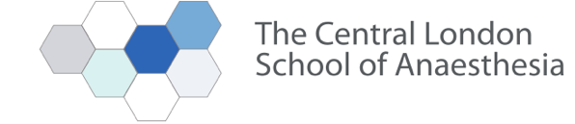

Post FRCA Teaching Programme

Vascular Study Day

This teaching day will be pre-recorded with material available to view from the
29th October for 4 weeks.

Link to folder: vimeo.com/user/120514156/folder/5790797

Please register with HEE to attend and fill out the feedback forms

Anaesthesia Talks:

Prehabilitation - Dr Louisa Shovel, Royal Free Hospital

CPET - Dr Clare Morkane, Kings Hospital

Preassessment and preoptimisation - Dr Marta Campbell, Royal Free Hospital

Anaesthesia for AVM surgery - Dr Suehana Rahman, Royal Free Hospital

The ruptured AAA – Dr Lasitha Abeysundara, Royal Free Hospital

Surgical Talks:

Aortic dissection - Mr Ben Adams, Barts Heart Centre

Endovascular Surgery - Miss Anna Prent, Royal Free Hospital

Peripheral Vascular Surgery - Mr Mark Portou, Royal Free Hospital

Carotid Surgery - Mr Daryl Baker, Royal Free Hospital

