Pan North Thames Post-FRCA Study Day (ST5-7)

Higher Pain Study Day Friday 26th November 2021

Venue: MS Teams link via HEE

Dr Ian Goodall & Dr Ajoy Pandit

13:15 – 13:30 | Registration and sign in
13:30 – 14:15 | ICU/COVID and Pain update | Dr Harriet Kemp  NIHR Clinical Lecturer & Anaesthetist  Imperial College Londont
14:15 – 15:00 | Pain management in military settings | Lt Col Alex Kumar  Consultant in Anaesthesia, King's College Hospital, & Pain Medicine Chelsea & Westminster Hospital, & Defence Medical Rehabilitation Centre (DMRC-Stanford Hall).
15:00 – 15:15 | Tea break
15:15 – 16:00 | Post-surgical Chronic Pain | Dr Ian Goodall  TPD Chronic Pain North London, Clinical Lead for Pain Medicine. Chelsea & Westminster Hospital
16:00 – 16:45 | Acute and chronic pain management in paediatric patients TBC | Dr Ben Thomas  Consultant in Anaesthesia & Pain Medicine, Chelsea & Westminster Hospital
16:45 – 17:15 | Pain research and recent advances | Dr Vivek Mehta  Consultant in Pain Management & Clinical Network Director Pain Services. Barts Health NHS Trust
17:15 – 17:45 | Q&A and Close | Dr Ian Goodall & Dr Ajoy Pandit

Please note: Please register for the study day. : Study day will be held online on MS Teams link via HEE. Presentations/Programme is subject to changes.

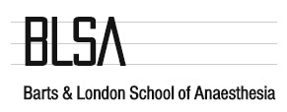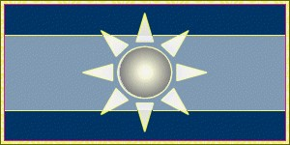
The Central London School of Anaesthesia

Post FRCA Study Day

Barts and the London School

Central London School

Imperial School

